**Forcast Content Writing Assignment**

**Assignment 1:Python Libraries**

Q1. Explain the multidimensional matrices and their indexing in NumPy in an interactive way?

Ans-

**Lesson 1: What is NumPy?**

•NumPy is a Python library widely used for numerical computing.

•It provides support for large, multi-dimensional arrays and matrices, along with a vast collection of mathematical functions to operate on them.

•The core functionality of NumPy is its ndarray (n-dimensional array) object, which forms the foundation for working with multidimensional data efficiently.

**Lesson 2: Creating Multidimensional Matrices.**

•NumPy allows us to create multidimensional matrices using the **ndarray** object.

•Let's start by importing NumPy and creating a simple 2D matrix.

**INPUT:-**

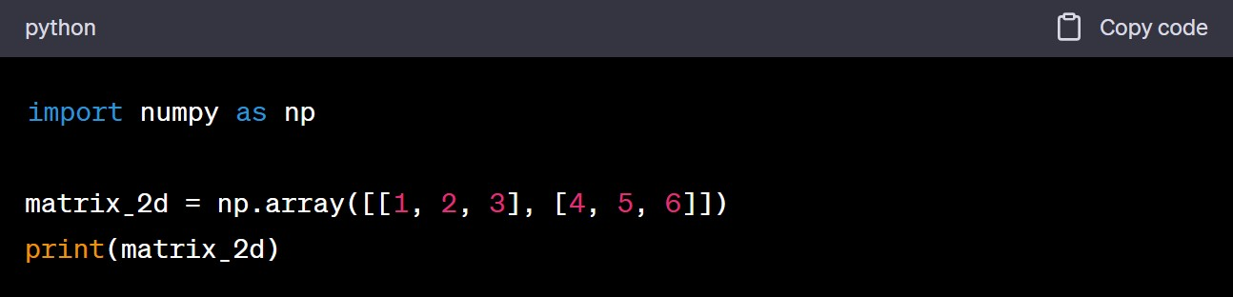

**OUTPUT:-**

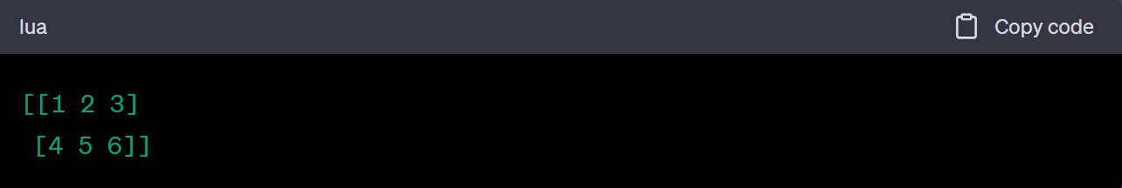

•The above code creates a 2D matrix with 2 rows and 3 columns.

•The print statement displays the matrix.

**Lesson 3: Matrix Shape , Indexing and Slicing.**

Shape:-

•Every ndarray has a shape, which describes the size of each dimension.

•We can access the shape of a matrix using the “shape” attribute.

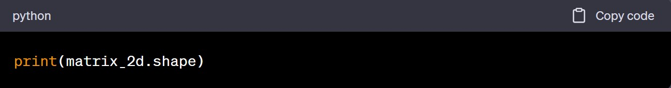

**OUTPUT:** The output will be (2, 3), indicating that the matrix has 2 rows and 3 columns.

Indexing(Accessing Elements):-

•In NumPy, indexing starts at 0, similar to other programming languages.

•We can use square brackets “[ ]” to specify the indices for each dimension.

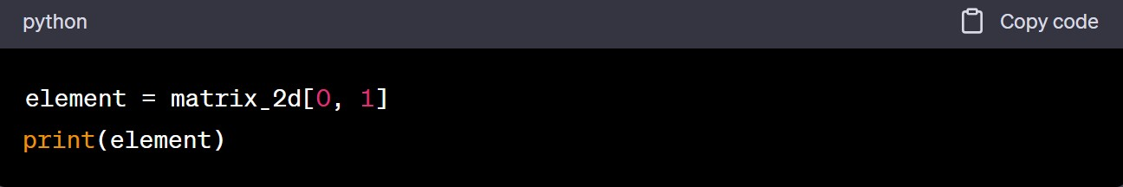

**OUTPUT:** In this example, we access the element at the first row and second column so the output will be 2.

Slicing:-

•Slicing allows us to extract a portion of a matrix using a range of indices.

•We use the colon : to specify a range.

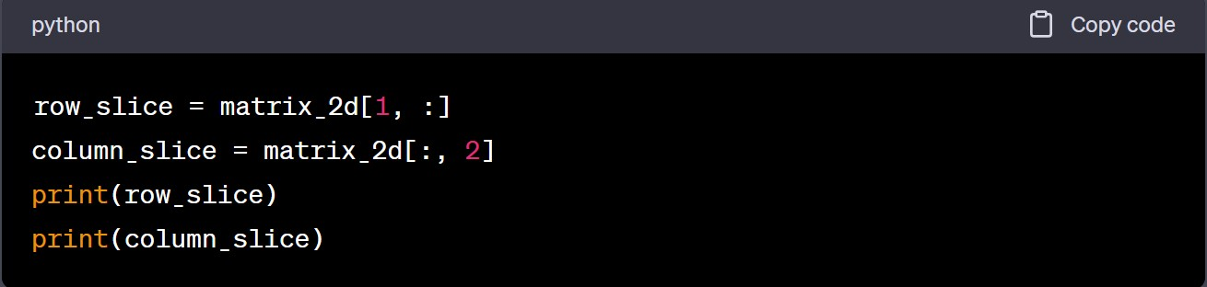

**OUTPUT:**in this code, we extract the second row and the third column hence output for row_slice will be [4 5 6] and for column_slice will be [3 6].

**Lesson 4: Modifying Matrix Elements.**

•We can also use indexing to modify individual elements of a matrix.

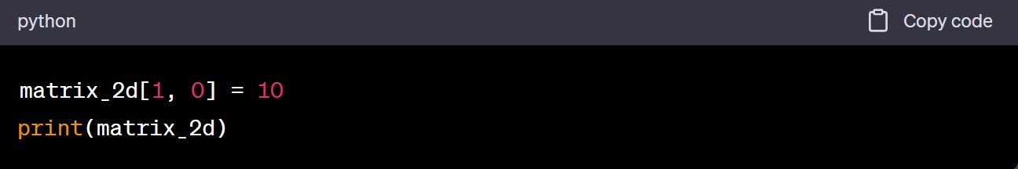

•In this example, we update the element at the second row and first column to 10.

•The output will be:

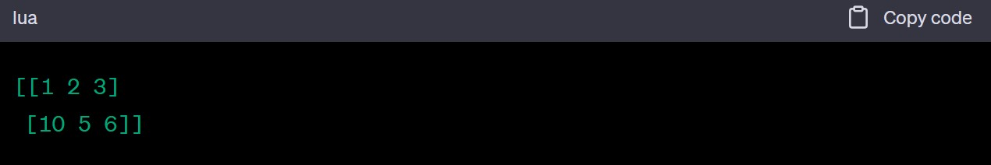

Q2. . Explain the use and working of Pivot Table in Pandas ?

Ans-

**Lesson 1: What is a Pivot Table?**

•A Pivot Table is a data summarization tool used to extract valuable insights from large datasets.

•It allows us to transform and restructure data, making it easier to analyze and derive meaningful conclusions.

•Pivot Tables are especially useful when working with tabular data, where we can group and aggregate information based on different dimensions.

**Lesson 2: Applications of Pivot Tables.**

Let's discuss some of the benefits of using Pivot Tables in data analysis:

•Data Summarization: Pivot Tables provide a concise summary of large datasets by grouping and aggregating data.

•Flexibility: They offer flexibility in rearranging, reorganizing, and exploring data from different angles.

•Insights and Patterns: Pivot Tables enable us to uncover patterns, relationships, and trends that may not be apparent in raw data.

•Interactive Analysis: They allow for interactive exploration, where we can quickly adjust and refine the table to answer specific questions.

**Lesson 3: Working with Pivot Tables in Pandas.**

•Pandas, a popular data manipulation library in Python, provides excellent support for working with Pivot Tables.

•Let's explore the key steps involved in creating and analyzing Pivot Tables using Pandas.

Step 1 - Loading Data

•The first step is to load the data into a Pandas DataFrame.

•We can read data from various sources, such as CSV files, Excel spreadsheets, or databases.

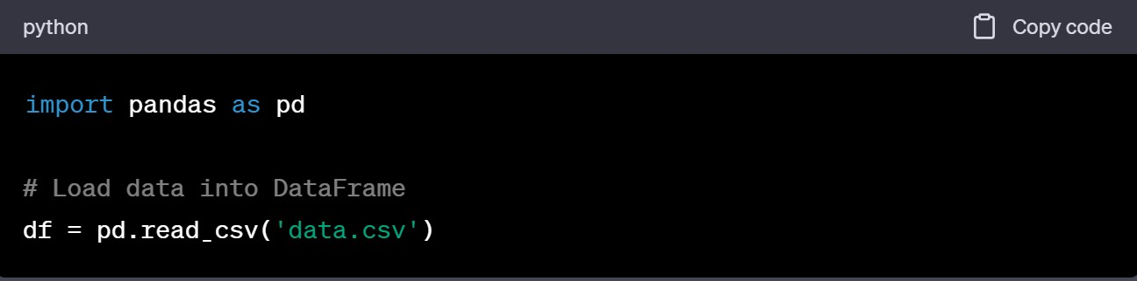

Step 2 - Creating a Pivot Table.

•Once the data is loaded, we can create a Pivot Table using the pivot_table() function in Pandas.

•The function takes several parameters, including the data, index, columns, and values.

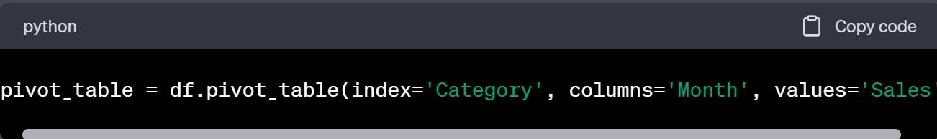

•In this example, we create a Pivot Table with the 'Category' column as the index, 'Month' column as the columns, and 'Sales' column as the values.

Step 3 - Aggregating Data

•Pivot Tables allow us to aggregate data by applying various functions, such as sum, mean, count, etc.

•We can specify the aggregation function using the aggfunc parameter in the pivot_table() function.



•In this code, we aggregate the 'Sales' data by summing the values for each category and month

Step 4 - Customizing Pivot Tables.

•Pandas provides additional options to customize Pivot Tables based on our requirements.

•We can specify multiple index or column levels, apply different aggregation functions, and handle missing values using the fill_value parameter.

Step 5 - Analyzing Pivot Tables

•Once the Pivot Table is created, we can analyze the data and extract insights.

•We can slice and dice the table, sort values, filter data, and perform calculations across different dimensions.

**Lesson 4: Conclusion**

•Pivot Tables in Pandas are a powerful tool for data analysis and summarization.

•They allow us to transform complex datasets into actionable insights quickly and efficiently.



**ASSIGNMENT 2:Unsupervised Learning**

Q1. Collaborative filtering using user-based similarity

Ans-

**Lesson 1: What is Collaborative Filtering?**

•Collaborative filtering is a recommendation technique that predicts a user's interests based on the preferences of other similar users.

•It relies on the assumption that users who have agreed in the past are likely to agree in the future.

•Collaborative filtering can be divided into two main types: user-based collaborative filtering and item-based collaborative filtering.

In this presentation, we will focus on user-based collaborative filtering.

**Lesson 2: User-Based Collaborative Filtering Process**

User-based collaborative filtering involves three main steps:

•Finding similar users: Similarity between users is calculated based on their past behavior or preferences.

•Selecting neighbors: A subset of similar users, called neighbors, is selected for making recommendations.

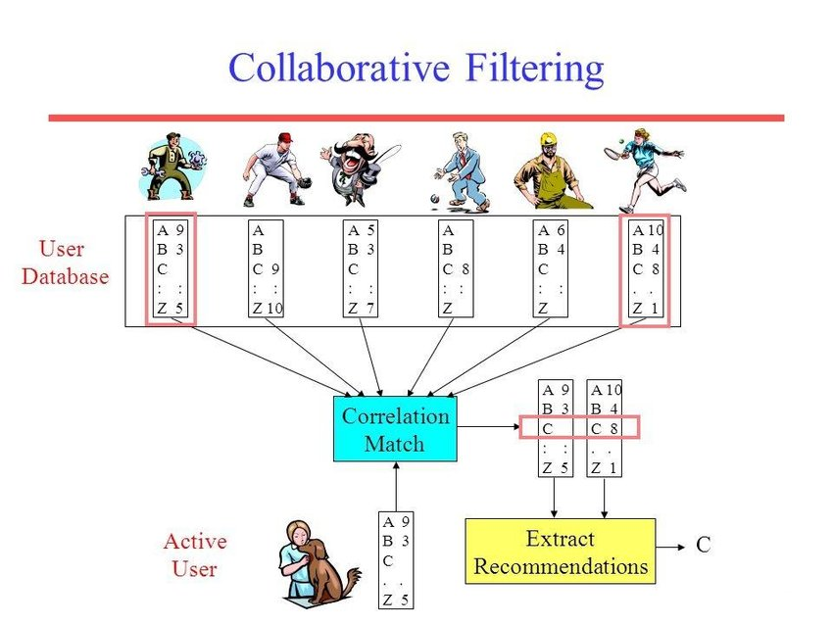•Generating recommendations: The system predicts a user's interest in an item by aggregating the preferences of the selected neighbors.

**Lesson 3: User-Based Collaborative Filtering Example**

Let's consider an example to illustrate how user-based collaborative filtering works:

•User A and User B have rated several movies.

•We calculate the similarity between User A and User B using a similarity metric.

•Based on the calculated similarity, we select a subset of neighbors, e.g., User C and User D.

•The system generates recommendations for User A by aggregating the preferences of the selected neighbours.

**Lesson 4: Advantages of User-Based Collaborative Filtering**

•Easy implementation: It is relatively straightforward to implement and understand.

•Serendipitous recommendations: It can suggest items that users may not have discovered otherwise, based on the behavior of similar users.

•Cold-start problem mitigation: It can handle new users with limited data by relying on the preferences of similar users.

•Domain independence: It can be applied to various domains, such as movies, music, books, and more.

**Lesson 5: Challenges and Limitations**

•Scalability: As the number of users and items grows, the computational complexity of finding similar users increases.

•Sparsity: The data used for collaborative filtering is often sparse, as users typically rate only a small fraction of available items.

•Data quality: Biased or noisy ratings can negatively impact the accuracy of recommendations.

•Cold-start problem for new users and items: Recommending to users with little or no data, or recommending new items with limited ratings, can be challenging.

Q2.K-means Limitations.

**Lesson 1: Overview of K-means**

•Select the desired number of clusters, K.

•Initialize K cluster centroids randomly.

•Assign each data point to the nearest centroid.

•Recalculate the centroids based on the mean of the assigned data points.

•Repeat steps 3 and 4 until convergence or a maximum number of iterations.

**Lesson 2: Programming in python**

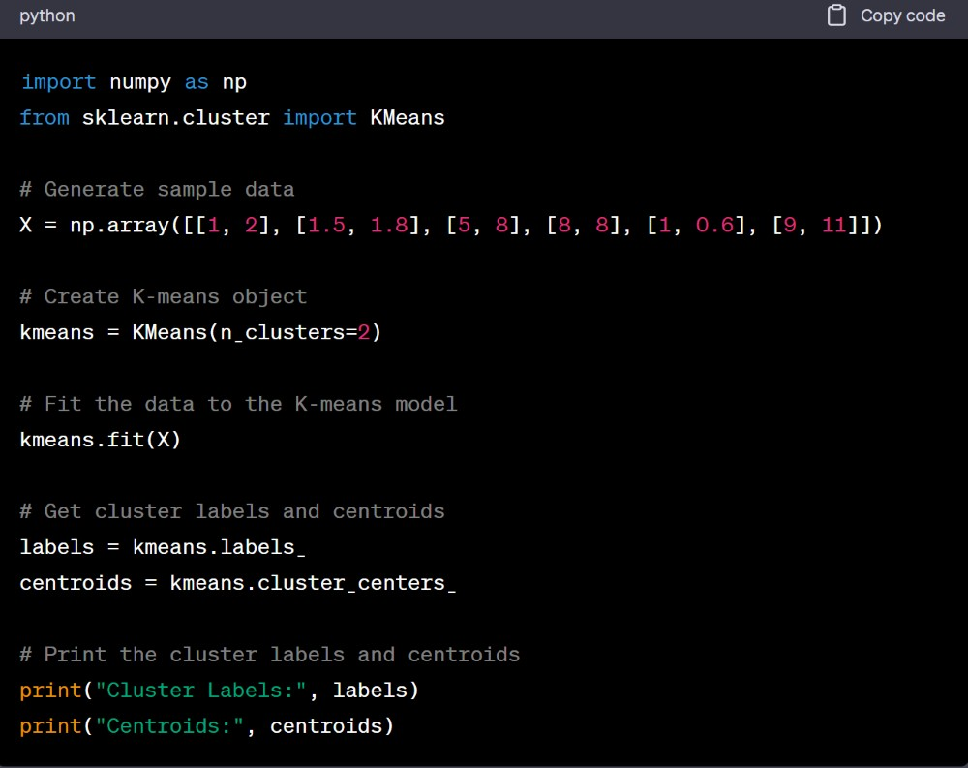

In this example:

•We import the necessary libraries, including numpy for data manipulation and KMeans from sklearn.cluster for the K-means algorithm.

•We create a sample dataset X with two-dimensional points.

•We instantiate a K-means object with n_clusters=2, indicating that we want to identify two clusters.

•We fit the data to the K-means model using the fit method.

•We retrieve the cluster labels for each data point using the labels_ attribute.

•We obtain the centroids of the clusters using the cluster_centers_ attribute.

Finally, we print the cluster labels and centroids.

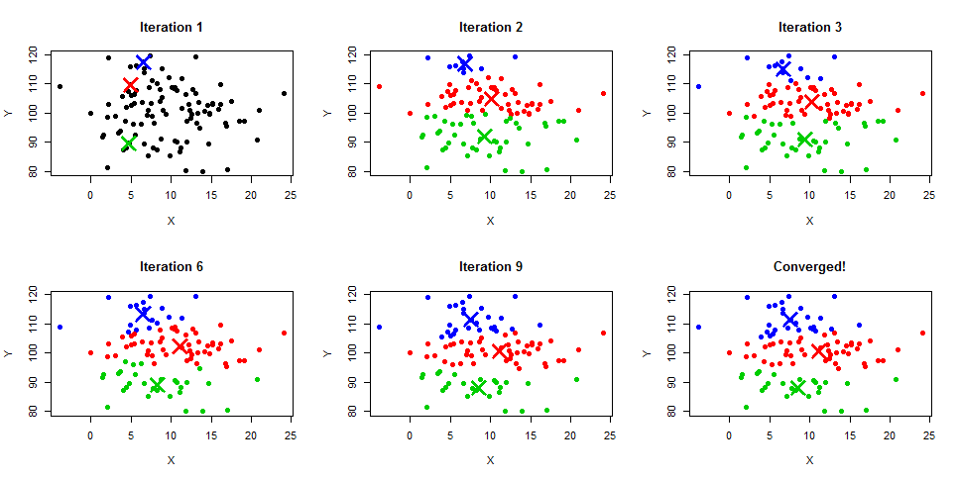

**Lesson 3: Applications**

•Recommender Systems: K-means clustering can be used in collaborative filtering-based recommender systems. By clustering users with similar preferences or item ratings, K-means can identify groups of users with common interests and provide personalized recommendations based on the preferences of similar users.

•Social Network Analysis: K-means clustering can be used to analyze social networks by clustering individuals with similar network connectivity patterns. This can reveal community structures, identify influential individuals, or detect patterns of interactions within the network

•Image Compression: K-means clustering can be employed for image compression by reducing the number of colors used in an image. By clustering similar colors together, K-means can represent the image with fewer color values, resulting in reduced file size without significant loss of visual quality.

**Lesson 4: Limitations**

1.Sensitivity to Initial Centroid Placement:

•K-means is sensitive to the initial placement of cluster centroids.

•Different initializations can lead to different outcomes, resulting in suboptimal or varying clustering results.

2.Assumes Spherical Clusters and Equal Variance:

•K-means assumes that clusters are spherical in shape and have equal variances.

•It may struggle with datasets containing clusters of irregular shapes, different variances, or varying densities.

3.Requires Predefined Number of Clusters (K):

•K-means requires the number of clusters (K) to be predefined.

•Determining the optimal K value is subjective and can be challenging.

•Incorrect selection of K can result in suboptimal or misleading clustering results

4.Lack of Flexibility for Non-linear Boundaries:

•K-means assumes that clusters are separated by linear boundaries.

•It may not be suitable for datasets with non-linearly separable clusters, such as concentric circles or complex geometric structures

5. Sensitivity to Outliers:

•K-means is sensitive to the presence of outliers in the dataset.

•Outliers can significantly impact the position of the cluster centroids and distort the clustering results.

